**Experiment No :** 21

**Experiment name :** write a C program to find sum of Series : 1^2+ 2^2+3^2+4^2+….+N^2

**Methodology :**

In this program, we first read the value of N from the user. Then, we use a for loop to iterate from 1 to N. In each iteration, we calculate the square of the current number i (i.e., i^2) and add it to the sum variable. After the loop finishes, we print the final sum of the series.

**Flow-Chart :**

int n , i ,sum=0 ;

scanf("%d",&n);

yes

NO

Not print

Print total sum series

printf("%d^2 = %d", i , sum);

for(i=0 ; i<n ; i++)

I!=n

for(i=0 ; i<n ; i++)

sum = (n*(n+1)*(2*n+1))/6

**Code :**

#include<stdio.h>

int main()

{

int n , i ,sum=0 ;

printf("Enter the max valus of series : ");

scanf("%d",&n);

sum = (n*(n+1)*(2*n+1))/6;

printf("Sum of the series : ");

for(i=1 ; i<=n ; i++){

if(i != n ){

printf("%d^2 + ",i);

}

else{

printf("%d^2 = %d", i , sum);

}

}

return 0 ;

}

**Output:**

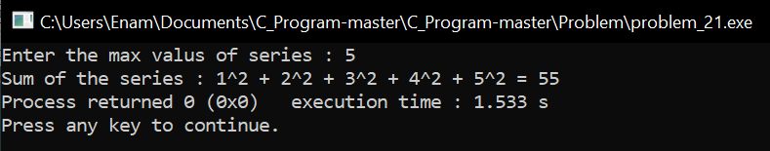

**Result discussion :**

Through this programming we have seen how to calculate the power. Suppose I take a series which is a list of five.